Create user accounts for student or applicants
- Navigate to My.Sentara.edu
- Select the Student Portal Homepage link:
- Select Create New Account.
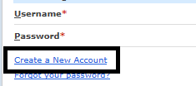
- Use SSN to create account:
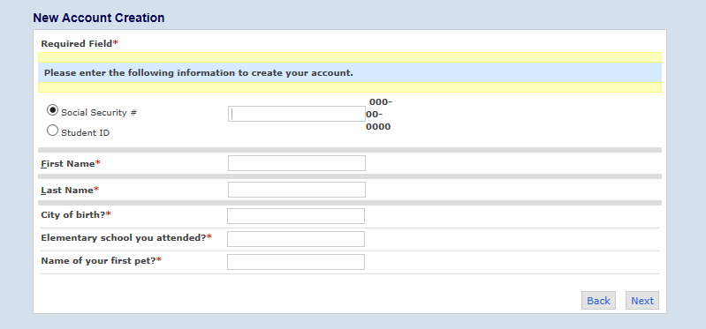
- The system should recognize the SSN and prompt to either use existing email or update to new email.
- Authentication email will be sent to complete account creation.
- If you are unable to create your account, please contact support using the contact information at https://scohshelpdesk.freshdesk.com/support/home .

